I got error when run template.fmb
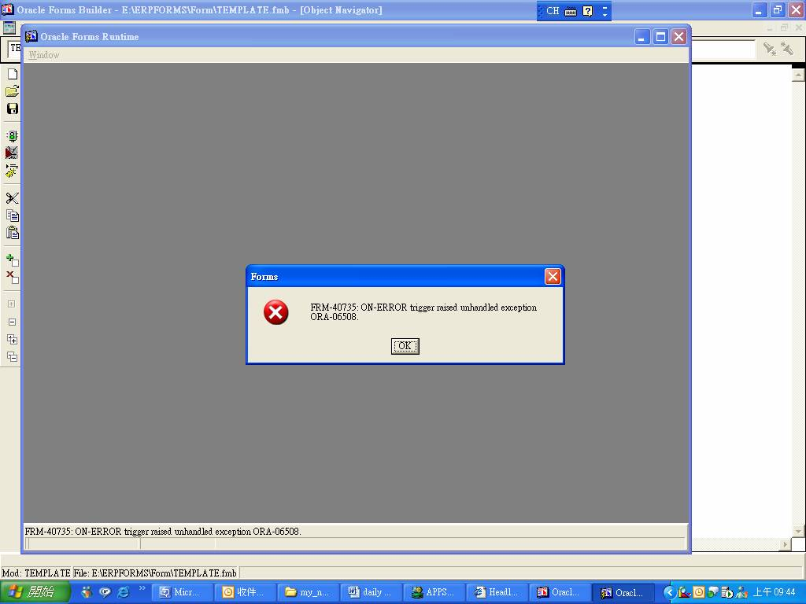

I check the attached library APPCORE.pll ,found package APP_EXPORT can not compile.
